**Quiz 1**

**CS 316, Fall 2020**

**Total points: 40**

**Each problem carries 10 points**

**Time: 60 + 10 Minutes**

**Name:**

1. A) Find the Base and Induction clause, write the recursive function (pseudo code), and draw the AR diagram for i = 6 for the series called “CS 316 Series”.

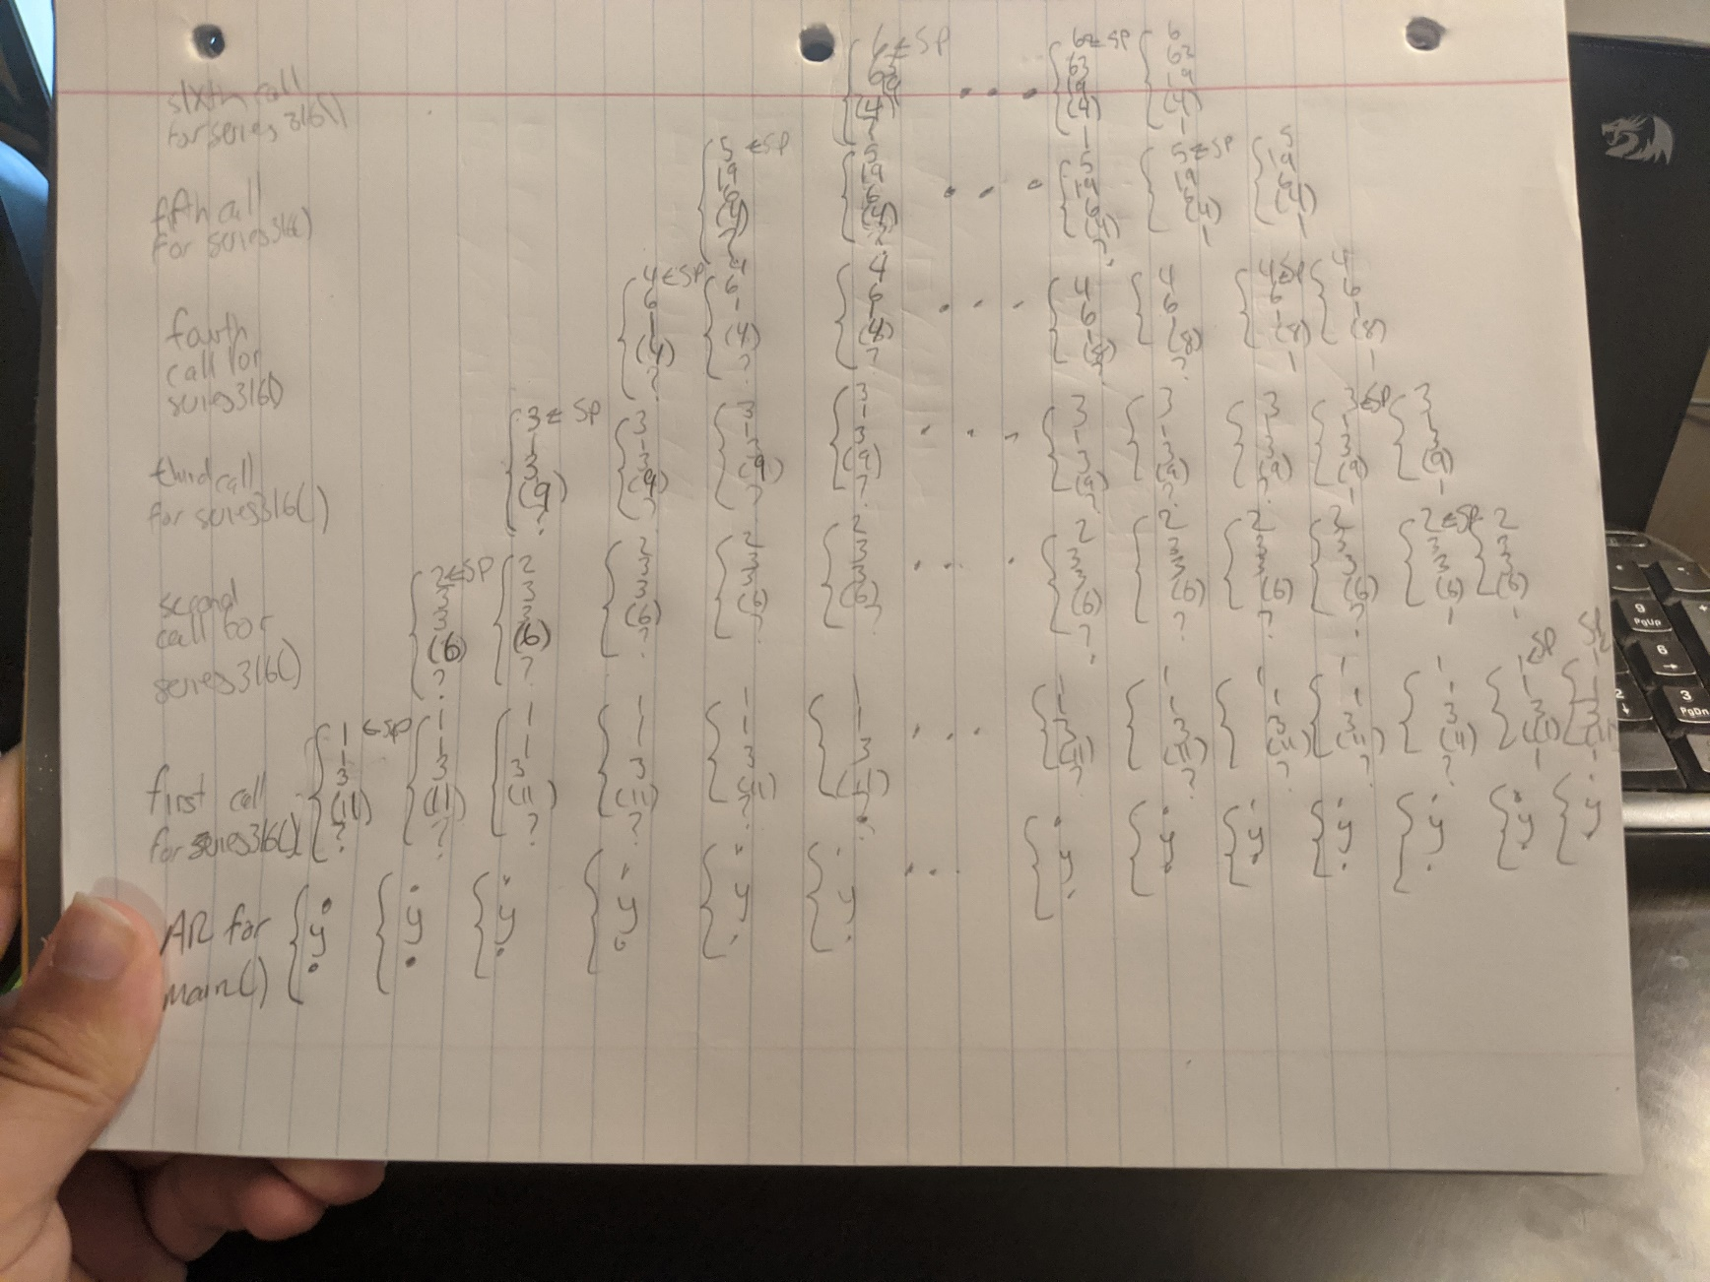“CS 316 Series” is a special series that starts with 3 (for n1) and 1 (for n2).

For i > 2, ni = ni-2 + 3*ni-1. For instance, the first four terms of this series are: 3 1 6 19.

**------ 10 points**

Base clause: n = 2 or n = 1

Inductive clause: If n < 2, continue the function

def series316(i=1, nm1=1, nm2=3):

    if (i > 2):

        print(nm1)

        return series316(i+1, nm2+(3*nm1), nm1)

    elif (i==1):

        return series316(i+1, 3)

    elif (i==2):

        print(nm1)

        return series316(3)

series316()

**Write solution or attach snapshot here.**

1. Find all the following 10 different traversals for the given BST.
2. Breadth First Traversal: Top-down, Left-to-right

**+ - * □ X / @ ~ α O % (scissors) #**

1. Breadth First Traversal: Top-down, Right-to-Left

**+ * - @ / X □ (scissors) % O α ~ #**

1. Breadth First Traversal: Bottom-up, Left-to-right

# ~ **α O % (scissors) □ X / @ - * +**

1. Breadth First Traversal: Bottom-up, Right-to-left

**# (scissors) % O α ~ @ / X □ * - +**

1. Depth First Traversal: Inorder, LVR

**~ □ – α X + / O * % @ (scissors) #**

1. Depth First Traversal: Inorder, RVL

**# (scissors) @ % * O / + X α - □ ~**

1. Depth First Traversal: Preorder, VLR

**+ - □ ~ X α * / O @ % (scissors) #**

1. Depth First Traversal: Preorder, VRL

**+ * @ (scissors) # % / O – X α □ ~**

1. Depth First Traversal: Postorder, LRV

**~ □ α X – O / % # (scissors) @ * +**

1. Depth First Traversal: Postorder, RLV

**# (scissors) % @ O / * α X ~ □ - +**

**Write solution or attach snapshot here.**

1. A) What is Threaded Tree? Why it is required? **------ 2 points**

A threaded tree is a tree that when you search it, it does not require a stack to traverse it. It is especially useful when you are searching a tree that is not balanced, to help find the best way to traverse the tree, as there are pointers on each node for which node to access next to decrease access time.

B) Draw the Inorder threaded tree for the given BST in problem 2. **------ 8 points**

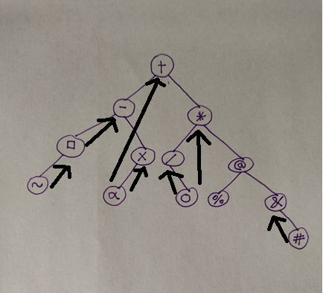

**Write solution or attach snapshot here.**

1. A) What are the issues in an imbalanced binary search tree? **------ 2 points**

An imbalanced binary search tree can lead to inefficient access times for nodes. For example, if the BST has one leg of height 2 and one leg of height 10, you are going to have, on average, a suboptimal search time as any items on the leg of height 10 will have a longer access time.

B) Define tail recursion and non-tail recursion. **------ 2+2 points**

Tail recursion effectively functions as a loop that runs until a function reaches an endpoint. Non-tail recursion goes into the recursion function until it finds a specific case, then returns with it and causes each call of the function to act accordingly.

C) What are the advantages and disadvantages of Recursion? **------ 2 points**

Recursion can be very simple to program, especially for programs that require very little recursive jumps.However, as you get into longer recursion, it takes up much more memory as more and more calls to the function lead to more and more space being taken up in memory.

D) How to avoid excessive recursion? **------ 2 points**

Minimizing the amount of necessary recursion calls to solve a function’s purpose is necessary to avoid overloading the stack and creating excessive recursion.

**Write solution or attach snapshot here.**